Brian Moyles – 21333461

Network

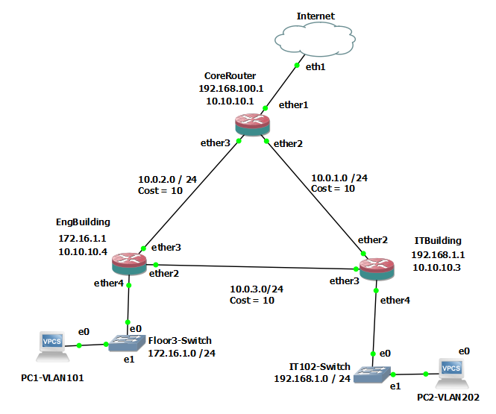

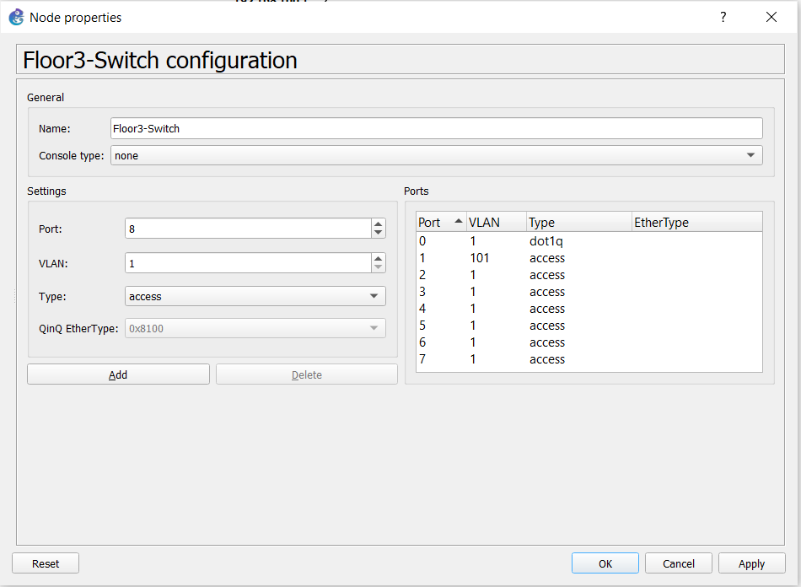

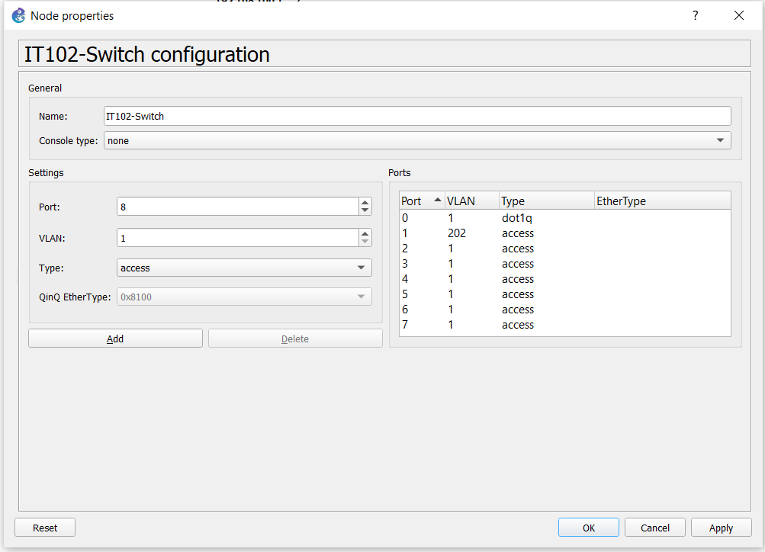

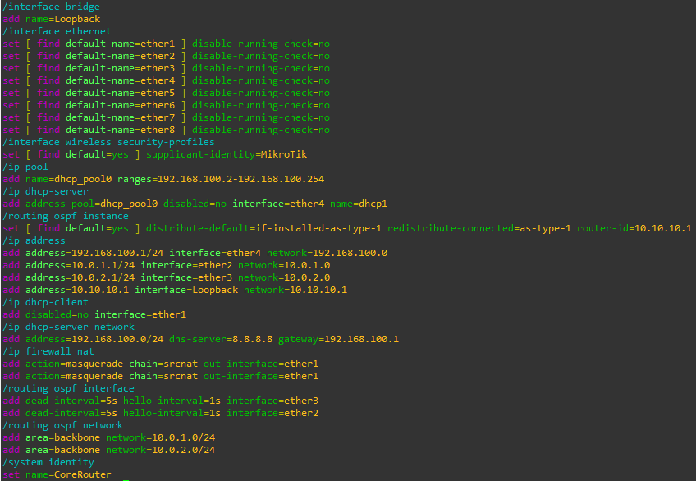

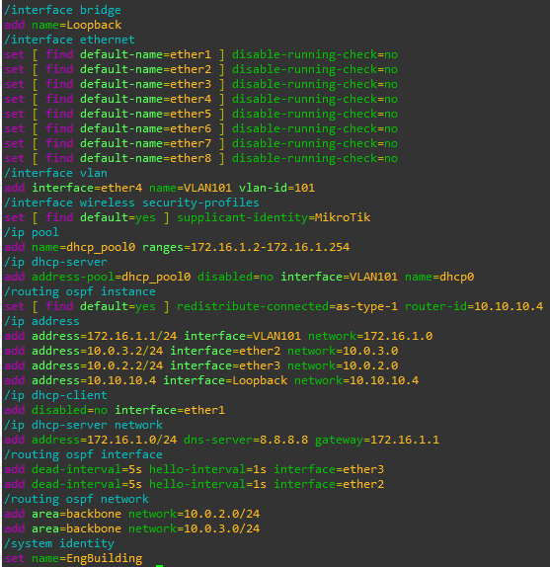

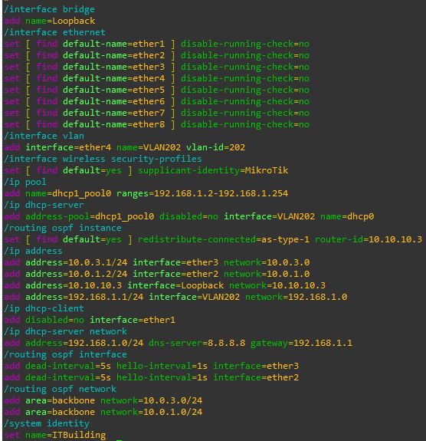

Verify the routers can ping each other

It Building Router Pinging Other Routers

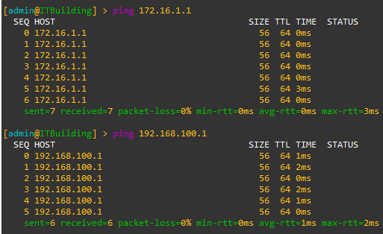

Engineering Router pinging other routers

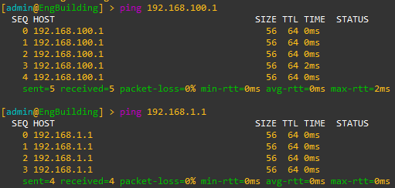

Core Router pinging other routers

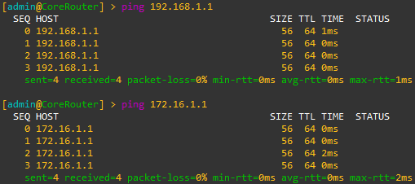

Verify routers can ping Loopback address

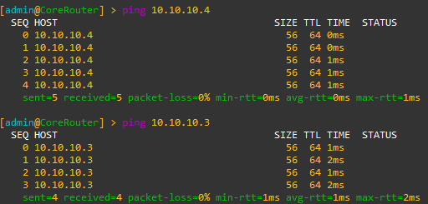

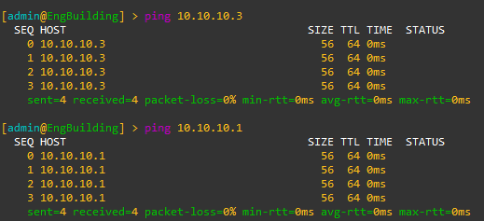

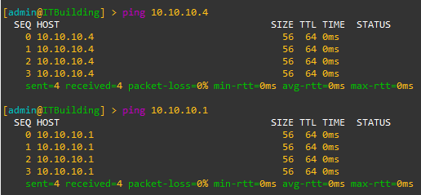

Verify PCs can ping each other

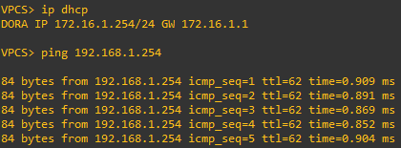

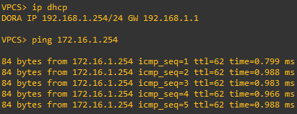

Verify that the internet is reachable from all devices and explain the meaning of each entry in the routing table of the Core Router

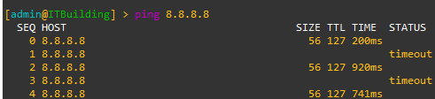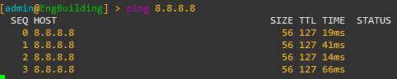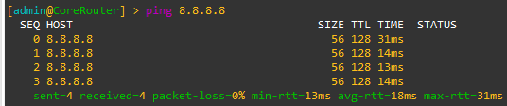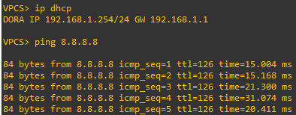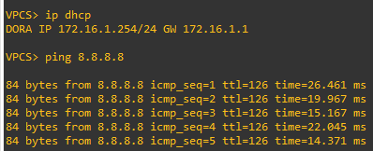

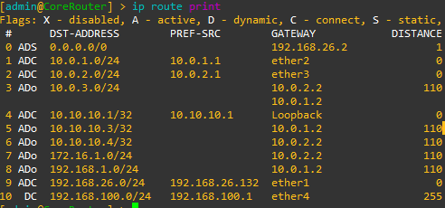

1. The default route with address 0.0.0.0/0 shows that any traffic with no other specific route will be sent to the 192.168.26.2 gateway
2. Entry #1 and #2 in the table are connected networks with connected routes as indicated by ‘ADC’. The destination addresses are 10.0.1.0/24 and 10.0.2.0/24 respectively. The pref-src are the source addresses used to send traffic from these networks. The gateways (ether2 and ether3) are the interfaces used. This is where the traffic for these networks is sent out through.
3. Entry #3 in the table is a static route with 2 possible gateways. The use of 2 gateways means if one fails, the router can use the backup route. It has a distance of 110 meaning it is less preferred.
4. Entry #4 is another connected route. It is for the loopback interface and has a distance of 0. The loopback IP address is 10.10.10.1/32 with a preferred source address of 10.10.10.1.
5. Entries #5, #6, #7 and #8 are all static routes to various networks. Each entry has different destination addresses for the routes, with each route configured for a specific network. They have a distance of 110 indicating a less preferred route.
6. Entry #9 is a connected route for 192.168.26.0/24. The traffic is routed through the ether1 interface.
7. Entry #10 is a dynamic route for the address 192.168.100/24. Traffic is routed through ether4. It is a dynamic route, likely through a routing protocol. It has a high distance of 255.

Explain what would happen if each router was not setup to redistribute connected networks

The router would not be able to automatically connect to the connected networks in its routing table.

Trace from PC1-VLAN101 to PC2-VLAN202 using ICMP

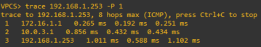

The trace route using ICMP from the PC1 to PC2 goes from 172.16.1.253 to 192.168.1.253.

The first hop is to 172.16.1.1. This is the IP address of the engineering building router that the VPC is connected to. The round-trip time is measured.

Hop #2 is to 10.0.3.1, which is the IP address on the IT building router with the ether3 interface. This router is connected to VPC2.

The final Hop is to the destination specified in the trace route command.

Run Long Ping and Suspend

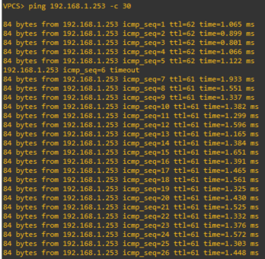

The sequence 6 ping is dropped, as seen above. That is the point at which I suspended the link between the VPCs. The ping then found another route to the VPC and the ping worked again at sequence 7. It is noted that the new route is longer as the time increases after the link is suspended.

The TTL also decrements after the suspension of the link, indicating the ICMP packets are taking another route to the destination.

Redo Trace

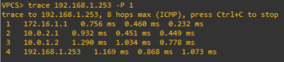

There is now another hop In the trace while the link is suspended. This is due to the packets using another route to get to the destination.

The first hop is to the engineering building router for the VLAN101.

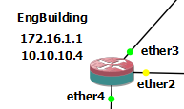

The second hop (10.0.2.1) is the new route the packets must take due to the suspended link. It goes to the core router first as this is the available route to the PC2. It goes to that IP address as 10.0.2.1 is the address of the ether3 interface, which is the link between engineering building router and core router. The screenshots below show the link between the routers and the correct address the packets take for the second hop.

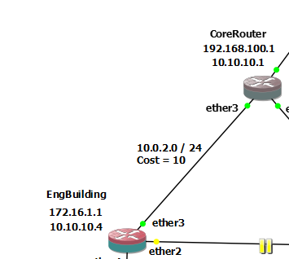

The third hop is from the core router to the it building router. Because the link from core router to it router is on ether2, the packets are sent to the address 10.10.1.2 as that is the address on the ether2 interface on the it building router. The screenshots below show that the hop goes to the correct address based on the configuration.

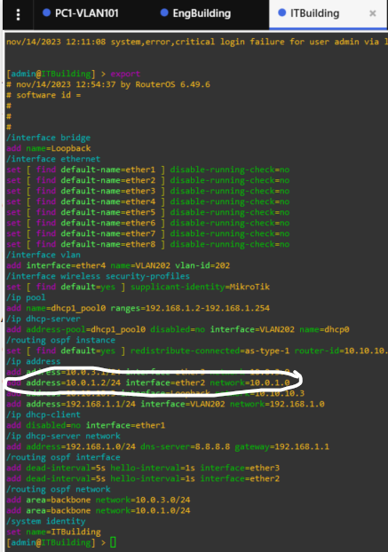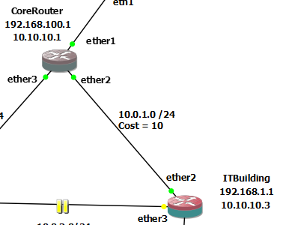

The final hop is to the VPC, which is the target destination. In conclusion, the extra hop is needed due to the new route taken because of the suspended link.

Wireshark Packet Capture

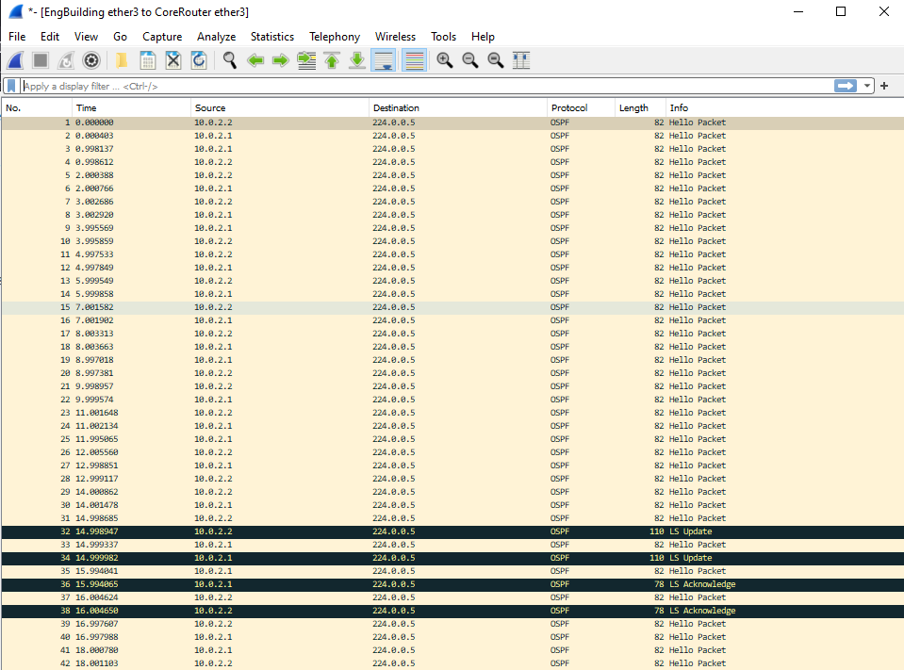

THE LS updates are used to distribute routing information between OSPF routers. Within the content of the capture there is a link state id, where the 10.10.10.4 router is advertising the link details to the router interface with the IP address 10.0.2.2.

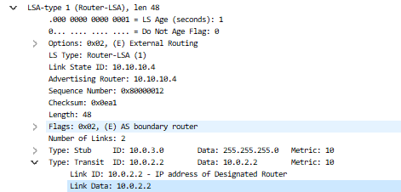

The link state acknowledges packets acknowledge the receipt of the link state update packets. The